Owned and operated by The Golden West Region of Scouts NSW this campsite is available for hire by groups and individuals from both inside and outside Scouting.

**Camp Minnamurra**

**Facilities Available**

**Accommodation:** 33 Bunk Style Accommodation and 300 Camping

**Amenities:** Separate shower and toilets for males, females and Adults

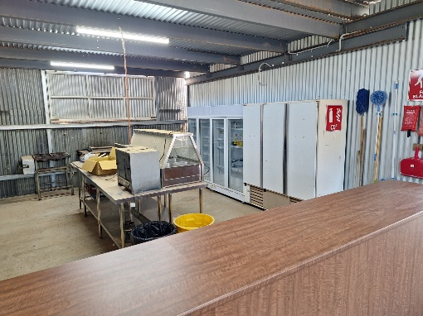Large dinning activity area seating 100

**Kitchen facilities:** Enclosed BBQ and kitchen area.

Main building has large kitchen facility Hot plate, 4 Burner Stove, Microwave, 2 x 2 door fridges, large freezer, large stainless steel prep benches, 8 ½ Bain-marie, 12 cup rice cooker, coffee drip machine pots pans, utensils, plates and Cutlery all available

.

**Hire Cost Scouts & Guides**

Camping: $12 Per person per night

Kitchen and gas usage fee: $20 per day

**Non Scout Usage** (exc. GST)

Camping: $15 Per person per night

Kitchen and gas usage fee: $20 per day

**Camp Minnamurra**

**General Rules**

* All Rubbish must be removed.
* Any damage caused to property and or contents will be charged as necessary.
* Scouts NSW does not provide 1st Aid Kits.
* Departure times to be agreed with warden as he will inspect prior to departure.

**Booking Form**

Name of hirer: Click here to enter text. Function: Click here to enter text.

Contact Person: Click here to enter text. Contact Number: Click here to enter text.

Email Address: Click here to enter text.

Address: Click here to enter text.

Date In: Click here to enter a date. Approx. time: Click here to enter text.

Date Out: Click here to enter a date. Approx. time: Click here to enter text.

Approx. Numbers: Click here to enter text.

Please phone or email us 2 weeks prior to your booking to confirm arrival times and expected numbers.

Facilities required (please tick)

Campground  Bunk style Cabins

**Bank and Contact details**

Westpac

BSB: 032-833

Account Number: 130551

Ref: Minnamurra *(Hirer name)*

Email: [vaughn.simmons@nsw.scouts.com.au](mailto:vaughn.simmons@nsw.scouts.com.au)

Phone: 0492 805 289

Please **NOTE** there is a non-refundable $50 booking fee to accompany this form

Camp Minnamurra COVID Plan is available upon request - Scouts NSW abides by and always endorses the current NSW Health Public Health Orders. All Scouts NSW guidelines should be read in association with the NSW Health Guidelines and Laws. In the event of a discrepancy or conflict in directions, the NSW Government and NSW Health guidelines takes precedent.